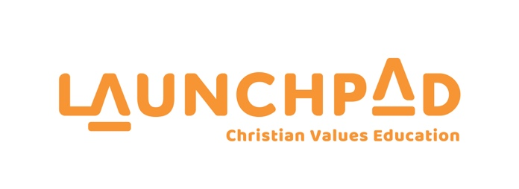

CHURCHES EDUCATION COMMISSION REPORT
TO THE GENERAL SYNOD / TE HĪNOTA WHĀNUI 2021/2022

Introduction from CEO – Geoff Burton

On behalf of the Churches Education Commission, I would like to say a huge thank you to the Anglican Church for your financial and large volunteer presence throughout our schools in Aotearoa.

I have reflected on how much we have to thank God for in His leading throughout 2021. It was of course a very challenging year with not being able to be in schools for significant periods of the year and the new challenge introduced towards the end of the year of mandatory vaccination for those entering schools.

Curriculum Revision – Bicultural

Over the last twelve months we have reviewed every aspect of the Launchpad three year curriculum to develop the bicultural perspective to our content and delivery.

Every document or resource now contains te reo Māori translations for key content such as unit and lesson titles, Bible verses, learning outcomes and karakia (prayers). Te ao Maori (worldview) values have been included as a theme for each unit.

Our new PowerPoint files now include a recording of karakia for presenters to use at the end of each Launchpad Champions session. Launchpad selected a set of key kupu (words) in te reo Māori that are now used across all branding and documents - for example: tamariki, aroha, kōrero and karakia.

The Launchpad website, marketing material and online training modules were also updated to include te reo Māori. Our next step is training for internal staff and volunteers as the new curriculum resources are rolled out around Aotearoa as well as continuing to add stories which relate to NZ History.
Launchpad Connect

Connect was a new initiative to recruit volunteers. Existing Launchpad volunteers were encouraged to register as hosts and invite people they knew who they thought would make good Launchpad presenters to their home for a coffee and share the idea.

The personal ‘tap on the shoulder’ is an effective way to connect with people who may have thought about becoming a presenter but are not sure how to start or may have questions.

Hosts were sent a link to a short video explaining how the event would run and a further video explaining what is involved in becoming a presenter.

Launchpad Connect events were held all over New Zealand, resulting in new volunteers who were then registered for training sessions.

Significant Challenges for 2020
Release of the new Education and Training Bill – Opt In

The new education and Training Bill released last year made it mandatory for all parents who wanted their child to participate in a religion Education programme to opt them in rather than the previous opt-out.

Opposition groups considered this a major win and viewed it as a positive step that would inevitably put an end to religious education in State Schools.

Launchpad offered assistance to schools in undertaking the task of acquiring parental permission by providing letters that schools could send home in the school bag.

Although we did lose a few schools, the majority have continued with the programme after receiving a majority parental vote in favour of opting-in. Some schools have reported an increase in attendance for Launchpad, following the introduction of opt-in.

In many ways, the programme has been strengthened in the eyes of schools by the affirmative action of parents saying they want their child to participate.

Engagement Needs 2021

Our greatest area of need is finding and training leaders for our programmes.

We have schools requesting the Launchpad programme but we are having to decline due to not having enough presenters. We find this heart breaking. God has been gracious in keeping this opportunity open and we believe we need to do everything we can to empower people to step up.

The greatest threat to the continuance of Launchpad and Chaplaincy is securing people to take the programme:

To make this happen we have invested in:

Leadership Recruitment
We have a need to extend our relationships with churches. CEC stands for Churches Education Commission and our very foundation is built on the support of churches. For a number of reasons church support has reduced considerably over a period of years and the impact of this has been significant on our available presenter pool.

We have contracted someone to take on the role of Church Engagement Representative to assist the regions in connecting with their local church communities and actively sharing the opportunities that exist to get involved in taking a Launchpad programme or taking a chaplaincy role.

Investing in conferences

Media Campaign - Radio and TV
We have partnered with Rhema Media to run a 12-month brand awareness and leadership recruitment campaign. This gives us a consistent voice on all Rhema channels throughout the year and is an effective way to communicate the need to potential leaders directly.

Launchpad Plus

One of our key goals has been to create digital content that our primary-aged students would relate to and engage with.

Our objective was to create episodes centred around values that can be used during Launchpad Champion sessions but could also stand-alone online as an option for our young viewers to engage with outside of the classroom.

After months in the planning we filmed a pilot late last year. The pilot was then tested in primary schools that already had our programme and the response was extremely positive by students and teachers alike.

Having gained useful feedback from the target market and then fine-tuned the format we were ready to produce the rest of the 3-4 minute episodes. The episode duration was selected as a time that sat well with the attention span of most students. The ‘swipe right’ generation tend to have shorter attention spans due to the rapid functionality of devices and fast-paced online offerings.

We believe this will be an excellent tool that our presenters can use in their lessons as well as making it available online and thus extending Launchpad beyond the classroom.

I want to say a sincere thank-you on behalf of Launchpad and Lifewalk for your incredible investment on an ongoing basis into the lives of thousands of children throughout this land. We simply could not do this without your help. We remain eternally grateful and thank God for the schools that open their doors to us every week.

Summation

We know the Launchpad programme continues to be vital in schools across our nation, so that means that as a team, we have more ground to cover and lots of work in front of us.

We remain hopeful that as we create new initiatives for schools and implement our te reo Maori curriculum, our relevancy will continue to align with the needs of school communities.

Geoff Burton CEO - Launchpad

